Comprehensive Creative Technologies Project: Project Title (in Tahoma, 24pt)

**Author Name**[my.email@live.uwe.ac.uk](mailto:my.email@live.uwe.ac.uk)  
Supervisor: Name

Department of Computing and Creative Technology

University of the West of England  
Coldharbour Lane  
Bristol BS16 1QY

*Screenshot/ image of the work (600 pixels high x 800 pixels wide .jpg)  
This image may be used for the degree show booklet. For white backgrounds please use 1/2pt black border.*

**Abstract**

Verdana, 9pt. This is a top line description of your project, not an introduction (that comes later). Please summarise your project, giving a bird’s eye view of your application/ software/ animation/ etc.   
What is the project? What is its aim? How was this realized in practice? Any key results/ insights that might benefit other professionals in the field? Don’t try to write anything new here, just repeat the main points achieved in your project succinctly. Short summaries like this are for people who just want to get to the core of your work without having to read the whole report.   
Note: the abstract is not included in the word count.

**Keywords**: term, term, term

**How to access the project** (not included in word count)

Verdana, 9pt. Provide any **project URLs** and/or details of where/how to access your project, and the ***URL of your final video***. If we need access to servers / administration interfaces please provide credentials and URLs. What we cannot access we cannot mark. You can change passwords after you receive your mark.

We also want to be able to see source code (if applicable), and the best way is to download it from your site or a Git server. Please clearly comment code to show us which sections are your own, and which sections stem from demos, examples, frameworks, libraries, OSS, online stores, tutorials or elsewhere.

If there is a particular method for providing access to your project you will need to provide instructions here. Also if there is anything we need to know about the work that will not be self-explanatory, then also provide brief instructions here.

**1. Introduction** ~400 words

The formatting for the main text is Verdana, 9pt.; the text should be justified, except for the references section and bibliography. Do *not* write in first person (“I started by exploring..”), but use 3rd person instead (“The project explores…”). In that way the report focuses on the project itself.

Any sub heading you create need to be 9pt bold. Only create sub headings if necessary, and only if substantial text sections follow after. Avoid breaking the text into too many short bits, each with its own heading, as this hinders the report’s flow. If you want to introduce a new thought, starting a new paragraph is often enough.

So in this introductory section, you need to briefly introduce the project within its professional context. State what it is about, what problems it solves, why it is important, interesting or valuable. What was it seeking to answer, how did it arise, why was it worth investigating?

* Also bullet list the
* key deliverables and
* project objectives here

**2. Research questions** ~200w

Having just introduced the project, lead the reader over to the key research questions. State your research questions simply, clearly and concisely.

**3. Literature review** ~1500w

Introduce your reader (assume they are a peer in your subject area) to the key literature and professional practice relevant for *this* project. This section must contain sufficient references to written and/or practice-based sources to show you have looked around sufficiently and that you can map out what is ‘current best knowledge’ or ‘current best practice’ within the relevant area(s).

If you are new to UWE Bristol Harvard referencing please read the [introduction to referencing](https://www1.uwe.ac.uk/students/studysupport/studyskills/referencing/introduction.aspx). Click here for [how to refer to (cite) a work in your text](https://www1.uwe.ac.uk/students/studysupport/studyskills/referencing/uwebristolharvard/howtociteawork.aspx). Also here for [General advice on how to format quotations in your assignment](https://www1.uwe.ac.uk/students/studysupport/studyskills/readingandwriting/writing/formattingyourwork.aspx) (includes when to use quotation marks). Follow guidance here on how to reference the following: [books](https://www1.uwe.ac.uk/students/studysupport/studyskills/referencing/uwebristolharvard.aspx#books), [journal articles](https://www1.uwe.ac.uk/students/studysupport/studyskills/referencing/uwebristolharvard.aspx#journalarticles), [films](https://www1.uwe.ac.uk/students/studysupport/studyskills/referencing/uwebristolharvard.aspx#films), [television programmes](https://www1.uwe.ac.uk/students/studysupport/studyskills/referencing/uwebristolharvard.aspx#television), [images and illustrations](https://www1.uwe.ac.uk/students/studysupport/studyskills/referencing/uwebristolharvard.aspx#imagesandillustrations), [official publications](https://www1.uwe.ac.uk/students/studysupport/studyskills/referencing/uwebristolharvard.aspx#officialpublications), [web pages](https://www1.uwe.ac.uk/students/studysupport/studyskills/referencing/uwebristolharvard.aspx#webpages).

**4. Research methods and Ethics** ~500w

Briefly tell the reader which research methods you will use to answer the research questions. Use the correct terminology when identifying research methods and give a brief rationale of why these methods were chosen (and not others). Try to convince the reader that the choices of method were appropriate for this project, and that it looked like they could provide the necessary answers.

If qualitative or user research was conducted, or research involving human participants, introduce the purpose of this, briefly describe the participants, sample size, process applied, response rate (if applicable), data analysis method and evaluation method.

Your reader also needs to know that all research methods were applied ethically and professionally at all project stages, meaning research and practice.

What you may need to mention in this section (depending on each project) is data collection, data storage, data disposal, gaining informed participant consent, respecting privacy, not causing harm either directly or indirectly through your project work, as well as how you were working to professional guidelines and standards. Non-disclosure agreements, intellectual property rights or copyright issues also need to be dealt with here.

Write a summary of the most important findings of the research phase and explain how exactly each of these findings will influence the follow-on stages of the project.

**5. Practice** ~2500 words

Now we have arrived at the practice section, the biggest part of this report. Here you guide the reader through the practical implementation stages of your project.

Do not describe every detail. Instead, try to put together an insightful and focused discussion by selecting the project-critical topics or stages. Tell the reader what these are and why they were so critical. Then lead the reader through. Make it clear to your reader when one topic / stage is done and the next one starts so they don’t get lost.

Demonstrate project management skills, for example: iterative development is often key when it comes to practice. How was this considered in the planning of the practice stages? How did the project deal with unforeseen user/ peer/ tutor feedback?

Demonstrate problem-solving skills: what problems did you encounter. How were they addressed or how was every method exhausted to arrive at the best possible solution? Use a few specific examples. Problems worthy of discussion could be conceptual, technical, practical, even legal (think copyright) or ethical (think user studies).

To help you make your points in this section convincingly, please insert quotes, graphs, screenshots, diagrams, tables (see Table 1), short code snippets etc. if useful and important.

| **Table example** | **1** | **2** | **3** |
| --- | --- | --- | --- |
| User 0 | 22.52 | 12.16 | 10.75 |
| User 1 | 22.72 | 12.26 | 10.60 |
| User 2 | 0.009 | 0.008 | 0.014 |

**Table 1:** Captionbelow the table, Verdana 8pt.

<p>   
For short code examples please use Courier Regular, 9pt. <br /> Put larger code examples into an appendix. Highlight code sections in colour if necessary.

</p>

Please note, all materials (figures, tables, etc.) need to be discussed in the main text, like this example picture of a hen (see Fig 1).

**Fig 1:** Captionbelow the image in Verdana 8pt. For white background images use a 1/2pt border in black.

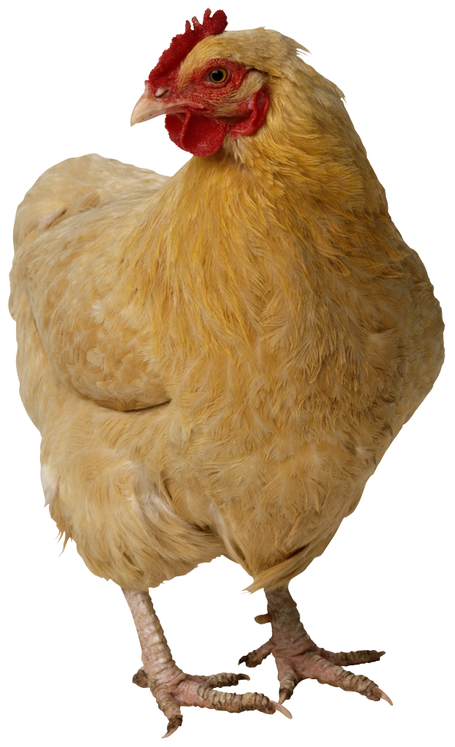

**6. Discussion of outcomes** ~1500

Now that the reader knows about key practice points, outcomes or results. Take a step back and reflect: what significance does this completed project have for its wider context? What could others draw from it? What problem does it improve on? (you may need some references here to situate the project convincingly within the context of previous work or artifacts). Critically analyse what has been achieved and if necessary, suggest alternative approaches.

Look back and close the loop: how and to what extent does the project respond to the research questions? In hindsight, were the methods and processes you chose the right ones? You want to underline the achievements of the project, but at the same time not hide any obvious omissions or shortcomings. Honesty about obvious flaws demonstrates awareness and insight.

Is there anything that would make this project *original* in a professional sense; e.g. have you discovered a new method as you went along? Or a new conceptual model that might help others understand a process better? Perhaps you’ve developed a more efficient workflow for research or practice? Streamlined some processes? Combined some tools or methods or contexts in new and efficient ways? Perhaps you have arrived at an artistic or expressive practice outcome? Improved on a service design by removing an obstacle in the experience flow?

**7. Conclusion and recommendations** ~400

This section should draw conclusions from completed research and practical work.

Make some recommendations here for next steps or further work. Imagine another student or professional picks up the project from where you left it. What would you recommend them to do?

Also think about the impact that could be achieved in the wider field. What could be the longer-term future of this project beyond UWE? A conference? An academic journal? An audiovisual festival? A creative competition?

How might this project benefit other users, professionals, society? Does the project have any commercial potential for example? Could it become a sellable product? Or should the code become a creative commons resource?

Find a useful sentence to end this report with. It is always beneficial to end on a positive.

**8. References** (=not included in word count – these are the sources you are actually quoting in this report; in alphabetical order)

Allan A, Schneider B and Miller C 2015 *Journal Name* **37** 074203

Bertrand J and Banes C 2009 *Journal Name* **23** 544

**9. Bibliography** (=not included in word count – these are any further items you have read around this topic; in alphabetical order)  
Author, A. (2009) *A Book About Student Projects*. Location Publisher.

Author, B (2008) ‘Journal Article’, *Digital Media Journal*, Vol 1/13, pp 13-23

University of the West of England (2009) *UWE Library Services:Study skills - The Harvard System* [Online] Available from <https://www1.uwe.ac.uk/students/studysupport/studyskills/referencing/uwebristolharvard.aspx>

[last access: 23 September 2009]

**Appendix A: Project Log** (not included in word count)

**Appendix B: Project Timeline** (not included in word count)

**Appendix C: Assets used in the Project** (not included in word count)

This is a list of project assets: all source materials used in the project. Clearly state which were produced by yourself and which were not. If not produced by yourself, include their reference, and status with regard to copyright/ creative commons licensing.

**Further Appendixes D, E … if applicable**\*(not included in word count)  
What could go here?

* Ethics: participant info sheets, consent form, interview questions, anonymized matrices, other anonymized summaries or analyses
* Any important design documents too large to insert in the main text
* Any important code sections not already on GitHub
* Any impotant large tables or diagrams
* Other relevant materials

*only insert meaningful materials here, please don’t just bulk this report up. Your main text should be able to stand on its own, without relying on information contained in appendixes. Check with your supervisor beforehand.